Table of Contents

PyCaret 1

Specifying the number of Folders 4

Interactive Visualizations in Google Colab 5

Plotting Feature Importance and Model Evaluation 6

Classification with Pycaret and Initial Conclusion 11

## PyCaret

PyCaret automates the process to find an optimized data model. With parameter adjustments, PyCaret can grid search model configurations and features.

**Note:** PyCaret by default displays outputs more nicely in Jupyter Notebook compared to PyCharm. As a result, for this demonstration a Notebook is recommended.

Example : Beginner Classification

This example is the first in a series which shows how to use PyCaret to find an optimized algorithm to predict when a person will default on a loan default.

<https://github.com/pycaret/pycaret/blob/master/tutorials/Binary%20Classification%20Tutorial%20Level%20Beginner%20-%20%20CLF101.ipynb>

First install PyCaret with the command.

|  |
| --- |
| pip install pycaret |

This code loads the loan data. Notice that .T is being used to trop the dataframe so unsightly word wrap is not present.

|  |
| --- |
| from pycaret.datasets import get_data  import pandas as pd  import warnings  warnings.filterwarnings("ignore", category=FutureWarning)  # Show all columns in same row.  pd.set_option('display.max_columns', None)  pd.set_option('display.width', 1000)  dataset = get_data('credit')  display(dataset.head(4).T)  display(dataset.describe().T) |

Table 1 shows a summary of the loan default data that is used to create the classification model.

Table : View of First 5 Rows of the Loan Default Data Set

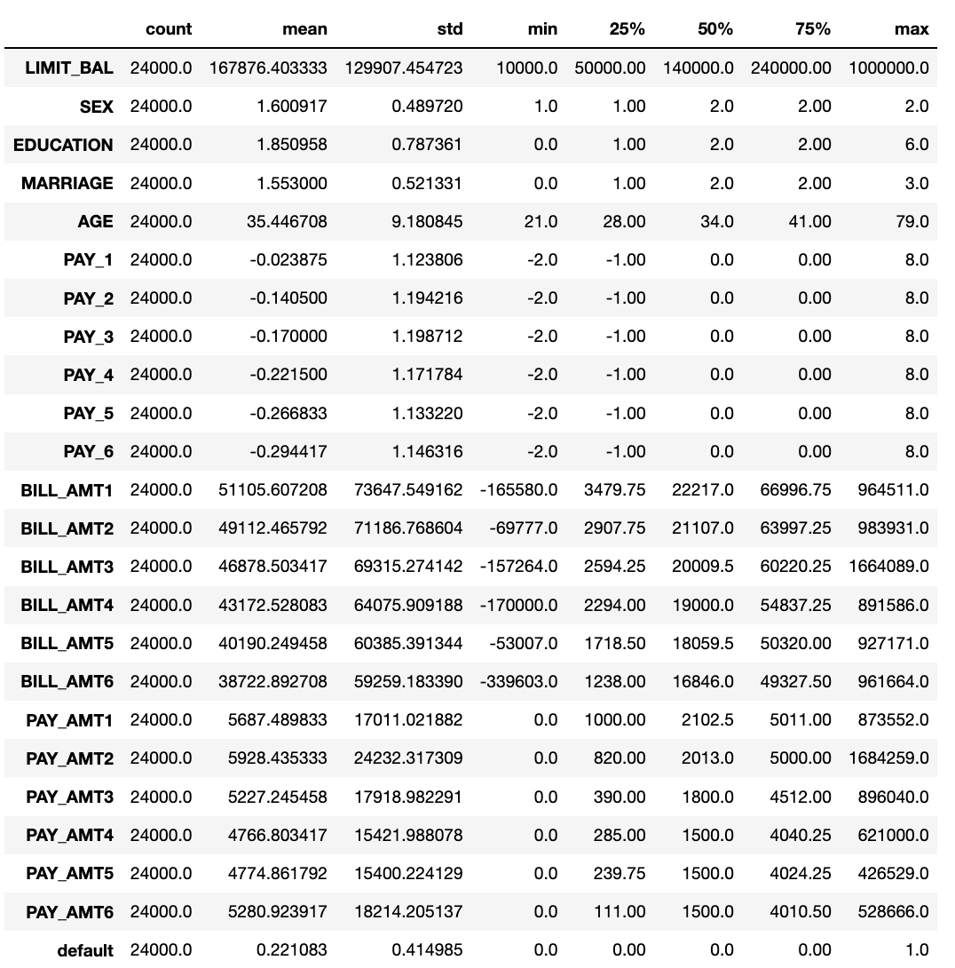

Example : Building a Model with PyCaret

This example continues from Example 1 to search for the best model. When running hardly any code at all you will notice that PyCaret identifies the RidgeClassifier as the best model.



**Note:** PyCaret will generate a lot of unnecessary output. If you use PyCaret, please do not blindly copy this output into your report since a lot of it does not really add any value to the report. Use proper care to ensure the data that you present is relevant to understanding the problem that is being solved.

The setup() function initializes the environment in pycaret and creates the transformation pipeline to prepare the data for modeling and deployment. setup() must be called before executing any other function in pycaret. It takes two mandatory parameters: a pandas dataframe and the name of the target column. All other parameters are optional and are used to customize the pre-processing pipeline (we will see them in later tutorials).

Unfortunately, the setup() function will not work with DataFrames so the code in this example uses a work around when splitting the data.

Note also that when running the setup() function you will be prompted to press enter but you could also type **quit** before pressing enter if you wish to stop the algorithm.



|  |
| --- |
| # Cannot use DataFrames with PyCaret's setup() function.  train = dataset.sample(frac=0.95, random_state=786)  test = dataset.drop(train.index)  train.reset_index(inplace=True, drop=True)  test.reset_index(inplace=True, drop=True)  print('Data for Modeling: ' + str(train.shape))  print('Unseen Data For Predictions: ' + str(test.shape))  # show data types.  from pycaret.classification import *  exp_clf101 = setup(data = train, target = 'default', session_id=123)  print(exp_clf101)  print("*** Showing best model")  best_model = compare_models()  print(best_model)  # Need this step for PyCharm  print("*** Showing best model")  regression_results = pull()  print(regression_results) |

Exercise (1 mark)

What are the two mandatory parameters of the PyCaret setup function?

|  |
| --- |
| pandas dataframe and the name of the target column |

Exercise (2 marks)

For example compare_models(sort = 'Recall') will sort the grid by Recall instead of Accuracy. Show a screenshot of the output after sorting the results by recall.

|  |
| --- |
|  |

## Specifying the number of Folders

To save on processing time, when comparing multiple models, you can specify the total number of folds.

|  |
| --- |
| compare_models(fold = 5) |

If creating a single model you can also specify the number of folds for it.

|  |
| --- |
| ridge = create_model('ridge')  tuned_ridge = tune_model(ridge, fold=3) |

Example Creating and tuning a single model.

When a model is created using the create_model() function it uses the default hyperparameters to train the model. In order to tune hyperparameters, the tune_model() function is used. This function automatically tunes the hyperparameters of a model using Random Grid Search.

This example shows how to create and tune a single model. You can see the parameters of a suggested best model in the output.

|  |
| --- |
| RidgeClassifier(alpha=1, class_weight=None, copy_X=True, fit_intercept=False,  max_iter=None, normalize=True, random_state=123, solver='auto',  tol=0.001) |

Here is the full sample for tuning the RidgeClassifier model with PyCaret.

|  |
| --- |
| from sklearn.linear_model import RidgeClassifier  from pycaret.utils import enable_colab  enable_colab()  from pycaret.datasets import get_data  import pandas as pd  import warnings  warnings.filterwarnings("ignore", category=FutureWarning)  # Show all columns in same row.  pd.set_option('display.max_columns', None)  pd.set_option('display.width', 1000)  dataset = get_data('credit')  print(dataset.T) # Transpose for a reader-friendly display  # Redo this for test_train_split  data = dataset.sample(frac=0.95, random_state=786)  data_unseen = dataset.drop(data.index)  data.reset_index(inplace=True, drop=True)  data_unseen.reset_index(inplace=True, drop=True)  print('Data for Modeling: ' + str(data.shape))  print('Unseen Data For Predictions: ' + str(data_unseen.shape))  ridge = RidgeClassifier(alpha=1.0, class_weight=None, copy_X=True, fit_intercept=True, max_iter=None, normalize=False, random_state=123, solver='auto',  tol=0.001)  tuned_ridge = tune_model(ridge) |

## Plotting Feature Importance and Model Evaluation

PyCaret offers methods to help detect the best model features and to evaluate the model.

Example : Plotting Feature Importance and Model Evaluation

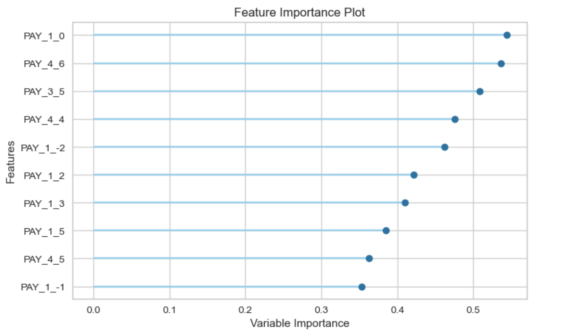

Here is the full program to draw the plot. To build this, add the following code in after the code from .

|  |
| --- |
| from pycaret.datasets import get_data  import pandas as pd  import warnings  warnings.filterwarnings("ignore", category=FutureWarning)  # Show all columns in same row.  pd.set_option('display.max_columns', None)  pd.set_option('display.width', 1000)  dataset = get_data('credit')  print(dataset) # Transpose for a reader-friendly display  # Redo this for test_train_split  data = dataset.sample(frac=0.95, random_state=786)  data_unseen = dataset.drop(data.index)  data.reset_index(inplace=True, drop=True)  data_unseen.reset_index(inplace=True, drop=True)  print('Data for Modeling: ' + str(data.shape))  print('Unseen Data For Predictions: ' + str(data_unseen.shape))  from pycaret.classification import *  exp_clf101 = setup(data = data, target = 'default', session_id=123)  print(exp_clf101)  ridge = create_model('ridge')  tuned_ridge = tune_model(ridge, fold=3)  #evaluate_model(tuned_ridge)  plot_model(tuned_ridge, plot='feature') |

To draw a confusion matrix add the following code to separate cell.

|  |
| --- |
| plot_model(tuned_ridge, plot = 'confusion_matrix') |

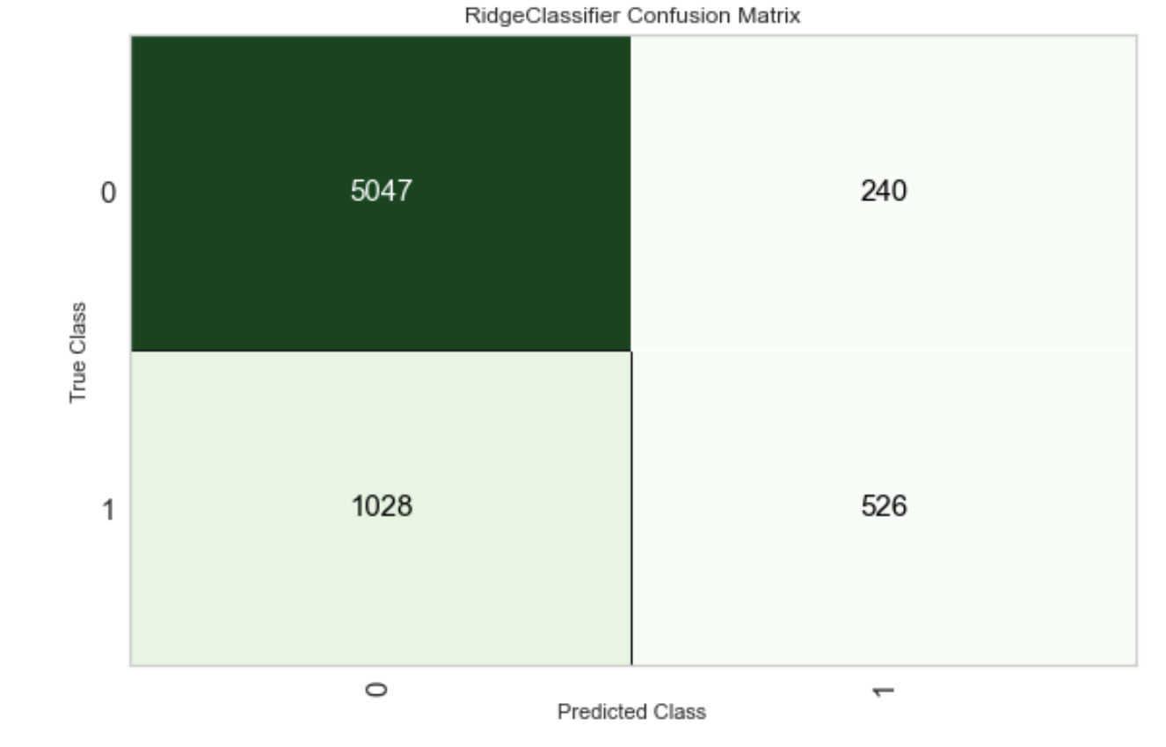

To display a precision-recall curve add the following code to a separate cell.

|  |
| --- |
| plot_model(tuned_ridge, plot = 'pr') |

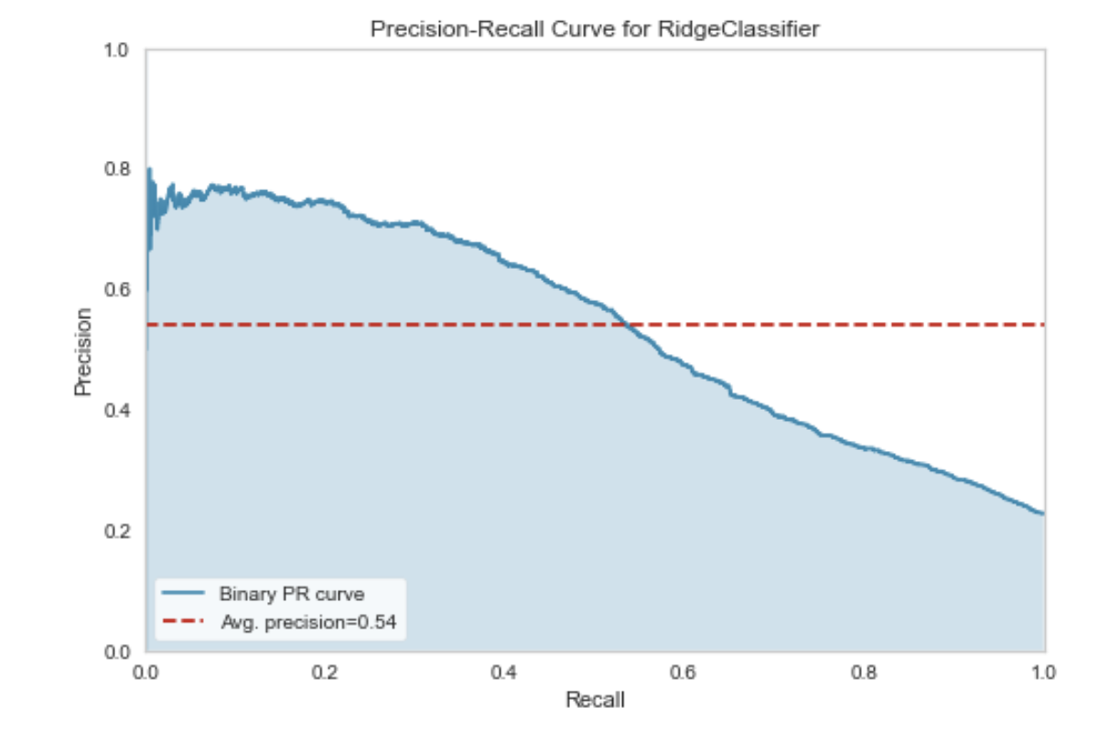

To detect the best set of hyperparameters for the ridge classifier, run the following instruction after running the code for Example 5.

|  |
| --- |
| evaluate_model(tuned_ridge) |

Selecting **Hyperparameters** option displays parameter values that are suggested to be used with the model.



This **Feature Importance** option gives a wider range of variable choices compared to the feature importance plot that was displayed earlier.



The **Feature Selection** option suggests that 25 features should be selected. Through experimentation I found that I could use about the top six or seven features and still get decent results.

Note: When clicking Feature Selection it will take quite a long time for the code to run. Be prepared to wait.



Example : Showing Confusion Matrix and Classification Report

To add a confusion matrix and classification report to the output, add the following code to the end of .

|  |
| --- |
| from sklearn.metrics import classification_report, confusion_matrix  print(classification_report(y_test, y_pred))  print(confusion_matrix(y_test, y_pred)) |

The evaluation metrics generated show how well the model does with predicting loan default.

|  |
| --- |
| precision recall f1-score support  0 0.83 0.96 0.89 937  1 0.71 0.31 0.43 263  accuracy 0.82 1200  macro avg 0.77 0.64 0.66 1200  weighted avg 0.81 0.82 0.79 1200  [[904 33]  [182 81]] |

Example : Building the Recommended Model

After following the recommended model approach from PyCaret, I then built a model using the recommended hyper parameters and model type. Instead of using all 25 of the top features I used 11 of the top features.

The output shows:

|  |
| --- |
| precision recall f1-score support  0 0.85 0.96 0.90 948  1 0.71 0.35 0.46 252  accuracy 0.83 1200  macro avg 0.78 0.65 0.68 1200  weighted avg 0.82 0.83 0.81 1200  [[912 36]  [165 87]] |

This code can be implemented in PyCharm.

|  |
| --- |
| from sklearn.linear_model import RidgeClassifier  from sklearn.model_selection import train_test_split  from pycaret.datasets import get_data  import pandas as pd  import warnings  warnings.filterwarnings("ignore", category=FutureWarning)  from sklearn.metrics import classification_report, confusion_matrix  # Show all columns in same row.  pd.set_option('display.max_columns', None)  pd.set_option('display.width', 1000)  df = get_data('credit')  print(df)  from sklearn.model_selection import train_test_split  # Re-assign X with significant columns only after chi-square test.  X = pd.get_dummies(df, columns=['PAY_1', 'PAY_2', 'PAY_3','PAY_4','PAY_5',  'PAY_6', 'MARRIAGE', 'EDUCATION'])  # show all rows.  pd.set_option('display.max_rows', None)  X = X[["PAY_1_0",  "PAY_4_6",  "PAY_3_5",  "PAY_4_4",  "PAY_1_-2",  "PAY_1_2",  "PAY_1_3",  "PAY_1_5",  "PAY_4_5",  "PAY_1_-1",  "MARRIAGE_0",  ]]  y = df['default']  # Split data.  X_train,X_test,y_train,y_test = train_test_split(X, y, test_size=0.05)  # Build logistic regression model and make predictions.  clfModel = RidgeClassifier(alpha=3.37, class_weight=None,  copy_X=True, fit_intercept=False, max_iter=None,  normalize=True, solver='auto', tol=0.001)  clfModel.fit(X_train,y_train)  y_pred=clfModel.predict(X_test)  print(classification_report(y_test, y_pred))  print(confusion_matrix(y_test, y_pred)) |

## Classification with Pycaret and Initial Conclusion

I think PyCaret is an excellent tool that helps to automate finding optimized models and top features. However, I also found that PyCaret is not perfect. It is still important to implement proper model validation and to experiment with other model types. Contrary to what PyCaret recommended; I could build a Logistic Regression model with the features that were recommended by PyCaret. The logistic regression model was competitive with the Ridge classifier model that was recommended by PyCaret.

Example : Building a Logistic Regression Model with the PyCaret Recommended Features

The Ridge model recommended by PyCaret does very well. However, this example shows that the logistic regression model is more competitive as a model than initially reported. Furthermore, results will vary over multiple runs so a proper validation process is required.

|  |  |
| --- | --- |
| Ridge Classifier | Logistic Regression |
| precision recall f1-score support  0 0.85 0.96 0.90 948  1 0.71 0.35 0.46 252  accuracy 0.83 1200  macro avg 0.78 0.65 0.68 1200  weighted avg 0.82 0.83 0.81 1200  [[912 36]  [165 87]] | precision recall f1-score support  0 0.83 0.96 0.89 933  1 0.68 0.31 0.43 267  accuracy 0.81 1200  macro avg 0.75 0.64 0.66 1200  weighted avg 0.80 0.81 0.79 1200  [[893 40]  [183 84]] |

To build this example, starting with , replace this line of code:

|  |
| --- |
| clfModel = RidgeClassifier(alpha=3.37, class_weight=None,  copy_X=True, fit_intercept=False, max_iter=None,  normalize=True, solver='auto', tol=0.001) |

with the following lines of code:

|  |
| --- |
| from sklearn.linear_model import LogisticRegression  # Build logistic regression model and make predictions.  clfModel = LogisticRegression(solver='liblinear') |

Example : Alternate (non-sklearn library)

PyCaret offers the ability to also include non-sklearn models (compatibility dependent). In this example, ngboost is included in the group of models which are compared with each other.

<https://towardsdatascience.com/5-things-you-are-doing-wrong-in-pycaret-e01981575d2a>

Before proceeding, run this command in a notebook cell to install ngboost:

pip install ngboost

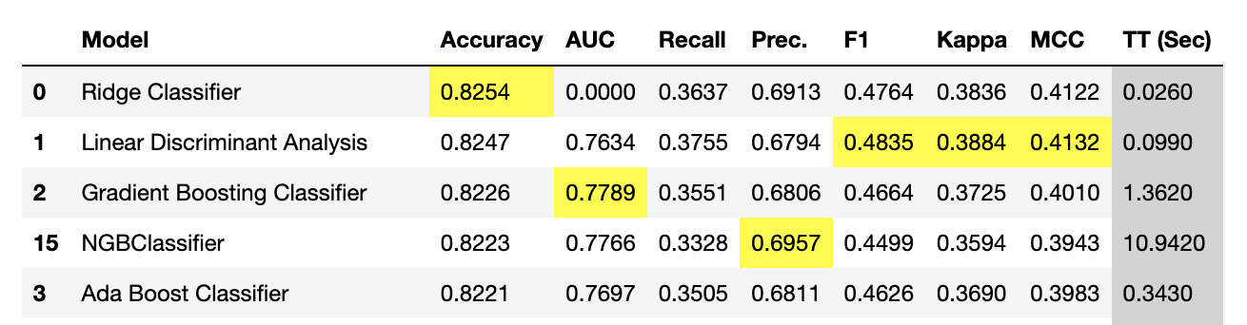

Here is the code which includes NGBClassifier.

|  |
| --- |
| from pycaret.datasets import get_data  import pandas as pd  # Show all columns in same row.  pd.set_option('display.max_columns', None)  pd.set_option('display.width', 1000)  dataset = get_data('credit')  print(dataset)  # Redo this for test_train_split  data = dataset.sample(frac=0.95, random_state=786)  data_unseen = dataset.drop(data.index)  data.reset_index(inplace=True, drop=True)  data_unseen.reset_index(inplace=True, drop=True)  print('Data for Modeling: ' + str(data.shape))  print('Unseen Data For Predictions: ' + str(data_unseen.shape))  # show data types.  from pycaret.classification import *  exp_clf101 = setup(data = data, target = 'default', session_id=123)  print(exp_clf101)  # Check best non-sklearn model (if compatible)  from ngboost import NGBClassifier  ngc = NGBClassifier()  ngboost = create_model(ngc)  best = compare_models(include=[  'ridge','lda','gbc','ada','lightgbm','rf','xgboost','et',  'lr','dummy','knn','dt','svm','qda','nb', ngboost]) |

Exercise (5 marks)

Show the hyper parameters that are recommended for the ngboost model.



Show a screenshot of the output here:

|  |
| --- |
|  |

Exercise (2 marks)

Use PyCaret to search for the best model for the iris_v2.csv data set to predict flower type. Show a screenshot of the models and their metrics. Identify the top model (there is no perfect choice here but please use reasonable judgement) and ensure that it is in the screenshot.

|  |
| --- |
| LDA because it is faster and higher AUC than KNN. |

Exercise (3 marks)

Using PyCaret, identify the optimized hyper parameters for your selected model. Show a screenshot here.

|  |
| --- |
|  |

Exercise (3 marks)

Using PyCaret, identify the top features for your selected model. Show a screenshot here.

|  |
| --- |
|  |

## Searching Regression Models with PyCaret

Example : Searching for Regression Models

Running this code in Jupyter shows how PyCaret could be used to search for regression models.

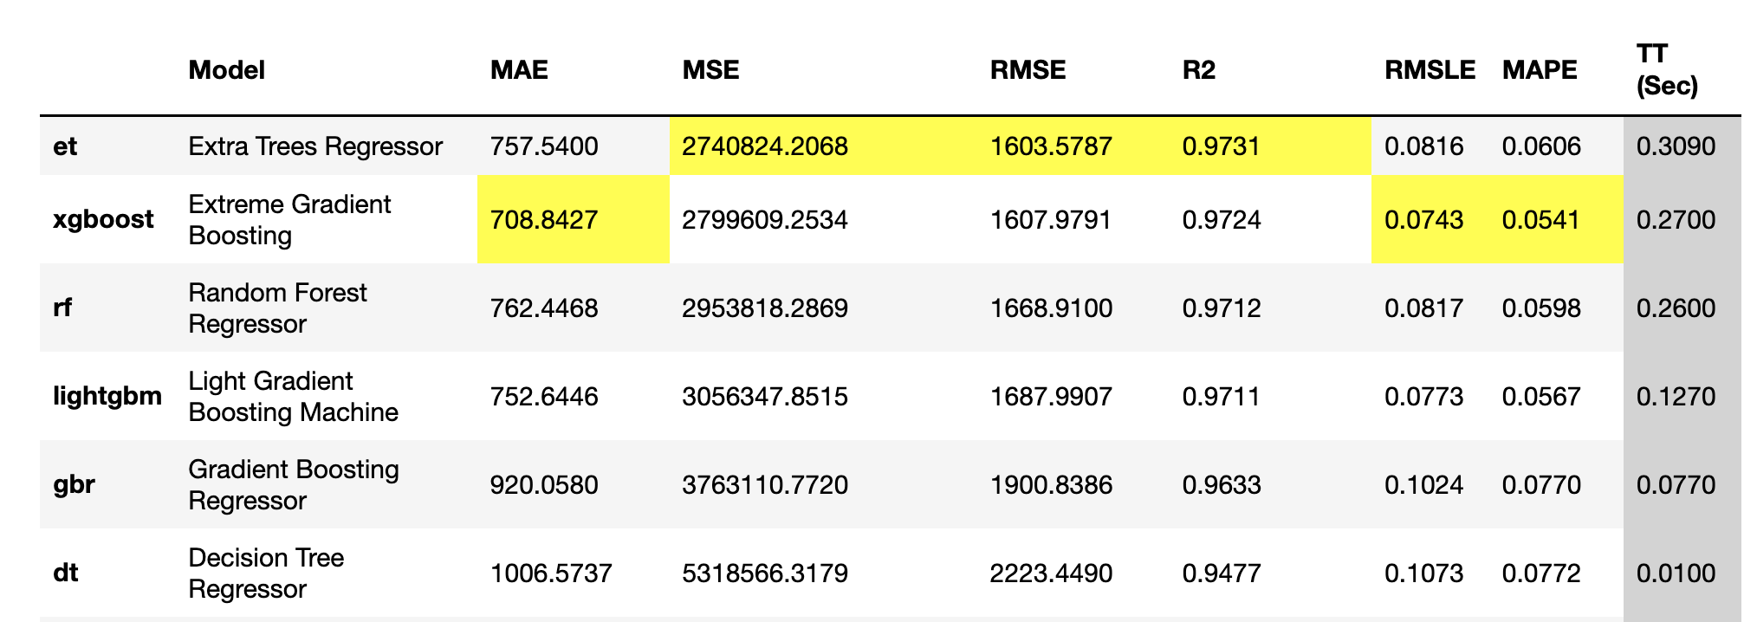

|  |
| --- |
| from pycaret.datasets import get_data  import pandas as pd  import warnings  warnings.filterwarnings("ignore", category=FutureWarning)  # Show all columns in same row.  pd.set_option('display.max_columns', None)  pd.set_option('display.width', 1000)  dataset = get_data('diamond')  # Get data and hold some back for testing.  data = dataset.sample(frac=0.9, random_state=786)  data_unseen = dataset.drop(data.index)  data.reset_index(drop=True, inplace=True)  data_unseen.reset_index(drop=True, inplace=True)  print('Data for Modeling: ' + str(data.shape))  print('Unseen Data For Predictions: ' + str(data_unseen.shape))  from pycaret.regression import *  exp_reg101 = setup(data = data, target = 'Price', session_id=123)  best = compare_models() |

## Tuning a Top Model

Once a top model has been identified, the best parameters and features can be identified.

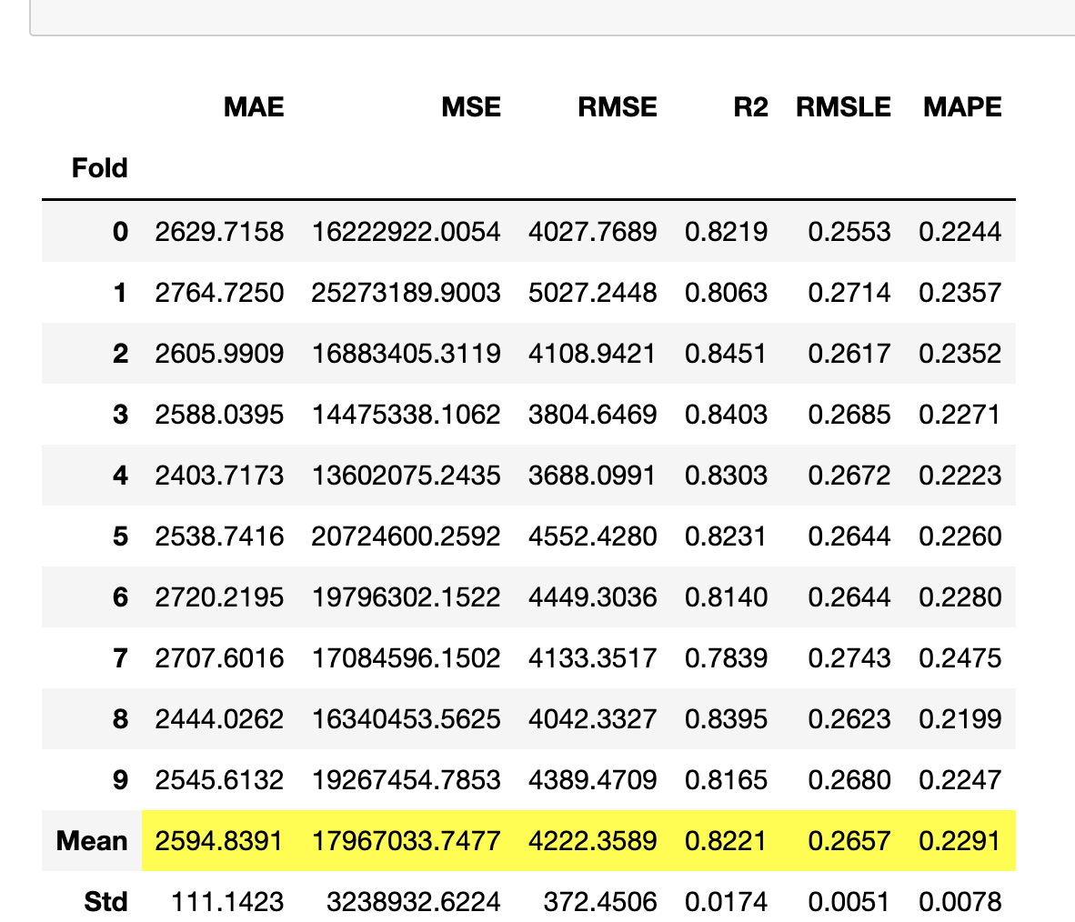

|  |
| --- |
| AdaBoostRegressor(base_estimator=None, learning_rate=0.05, loss='linear',  n_estimators=90, random_state=123) |

Example : Tuning a Regression Model

To generate the model evaluation metrics and optimized parameter listing run this code.

|  |
| --- |
| # Create model  ada = create_model('ada')  tuned_ada = tune_model(ada)  print(tuned_ada) |

Running the following instruction in a separate cell shows the residual error plot.

plot_model(tuned_ada)

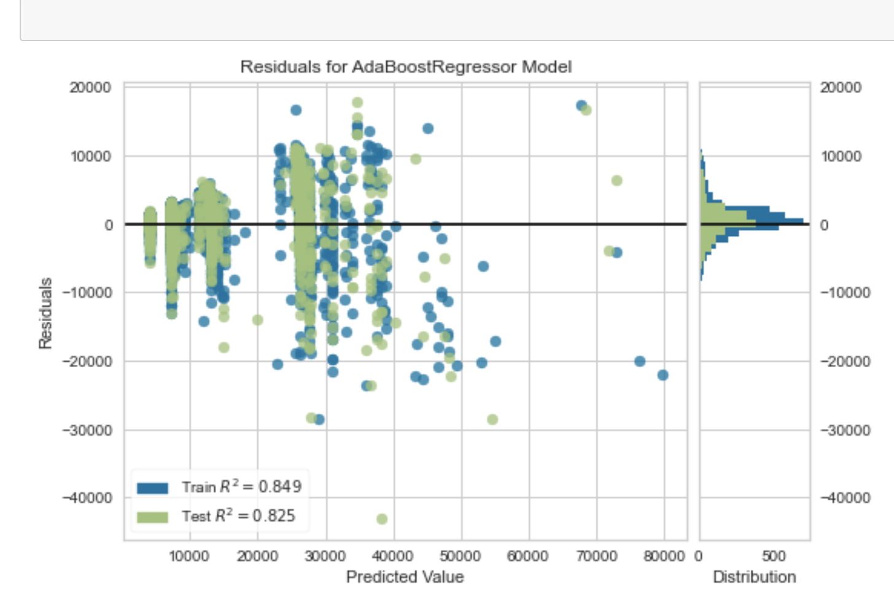

Features can be identified by running this code:

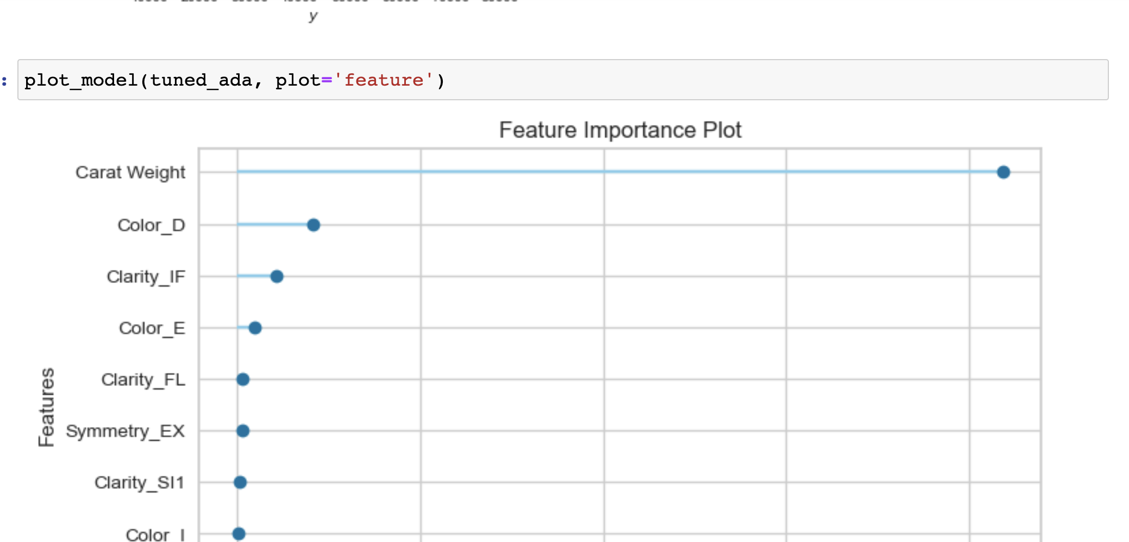

Exercise (5 MARKS)

Using the winequality.csv file, use linear regression in PyCaret to find the best model type. After identifying a suitable top candidate, show a screenshot of the optimized parameters for the model type here:

|  |
| --- |
| Best model type is Extra Trees Regressor |

Show a screenshot of the residual error plot here:

|  |
| --- |
|  |

Show a screenshot of the feature importance plot for the wine quality model here:

|  |
| --- |
|  |

## Next Steps

For more information on PyCaret see:

<https://github.com/pycaret/pycaret/tree/master/tutorials>